**CIS 572 Object Oriented System Design**

**Backward Tracing**

for

**Summary Report**

Submitted to:  Mr. Thomas Steiner

Submitted by: Vaishali Jain

**Table of Contents**

INTERFACE 3

CRC CARD 3

STATE DIAGRAM 4

DATA FLOW DIAGRAM (DFD) 4

CLASS DIAGRAM 5

SEQUENCE DIAGRAM 5

COMMUNICATION DIAGRAM 6

BUILD ERD 6

USE CASE DIAGRAM 6

USE CASE FLOW 7

# INTERFACE

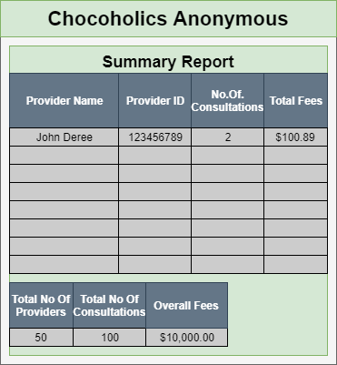

# CRC CARD

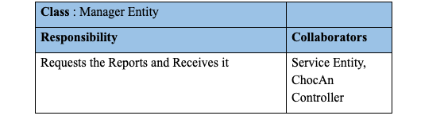

# STATE DIAGRAM

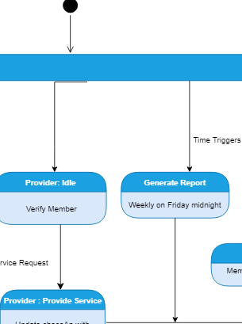

# 

# DATA FLOW DIAGRAM (DFD)

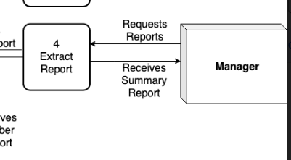

# CLASS DIAGRAM

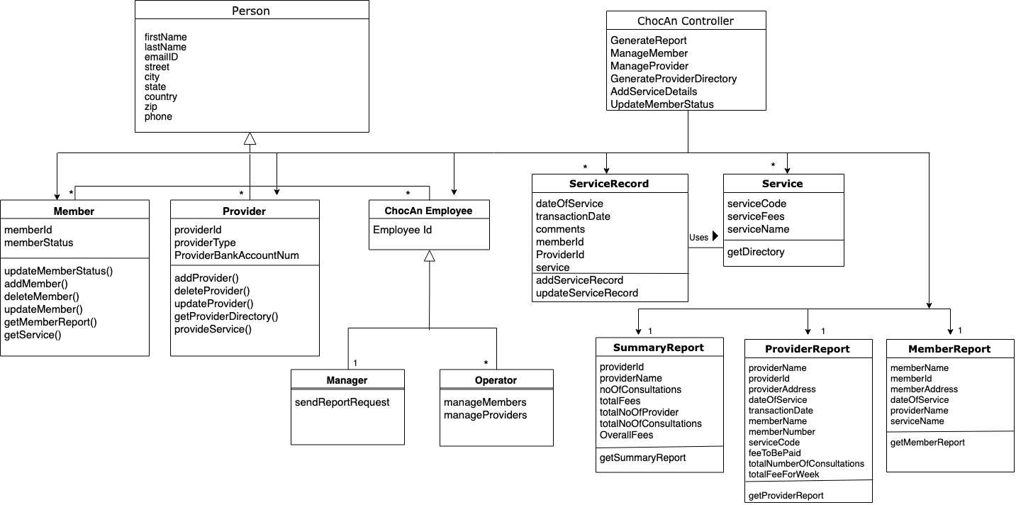

# SEQUENCE DIAGRAM

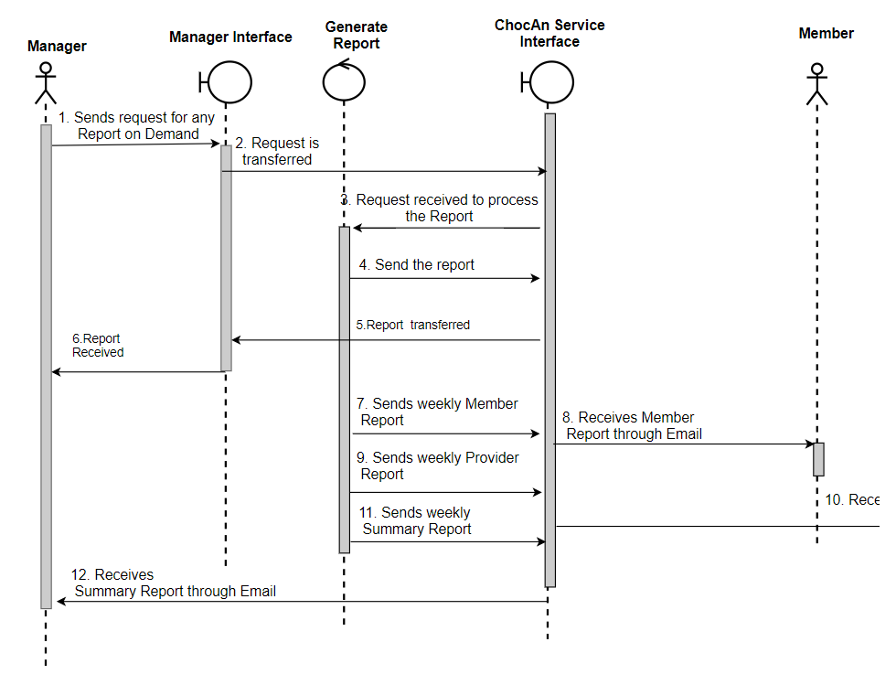

# COMMUNICATION DIAGRAM

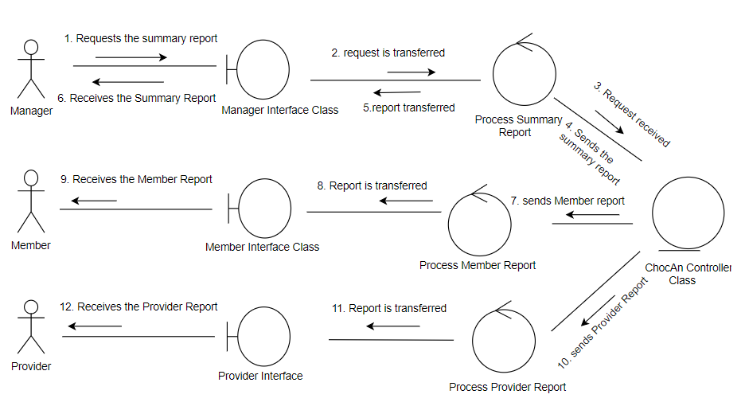

# BUILD ERD

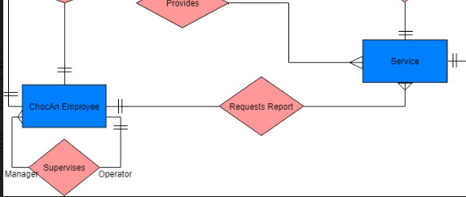

# USE CASE DIAGRAM

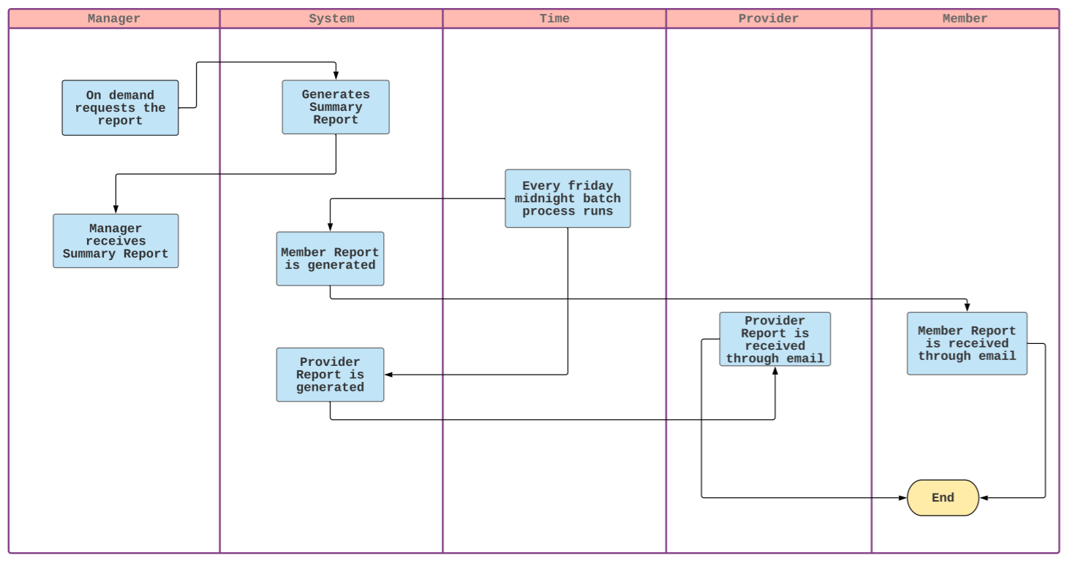

[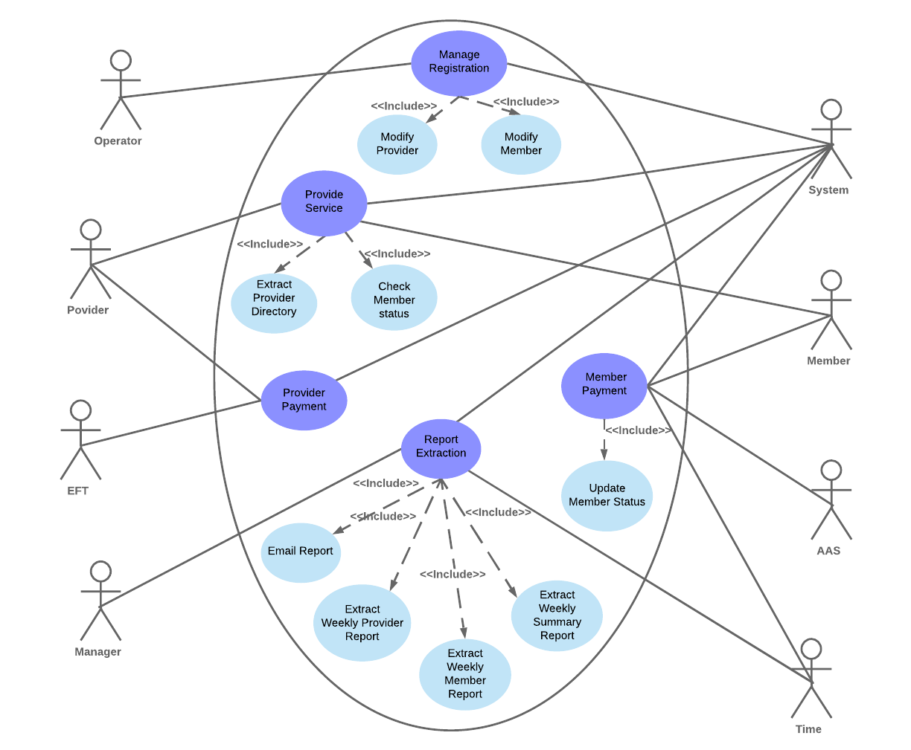](https://www.lucidchart.com/documents/edit/e4225d2b-b20f-493c-a91c-d3968eedc8df/0?callback=close&name=docs&callback_type=back&v=2008&s=612)

# USE CASE FLOW

Manager receives the Summary Report:

1. The report is requested by Manager at any time.
2. The system generates the Summary Report at any time.
3. The manager receives the Summary Report.

## 

# 

# 

# 

# 

# 

# 